**PROGRAMS :**

//To implement binary search

//Ethan Menezes 21co24

//Binary search implemented in the main program

#include<stdio.h>

int main(){

int low,high,mid,arr[20],n,x;

printf("Enter the size of the array\n");

scanf("%d",&n);

printf("Enter the elements in sorted order\n");

for(int i=0;i<n;i++)

scanf("%d",&arr[i]);

low=0;

high=n-1;

printf("Enter the element to be searched\n");

scanf("%d",&x);

while(low<=high) //loop to find the element to be searched

{

mid=(low+high)/2;

if(arr[mid]==x){

printf("Found %d at location %d",x,mid+1);

break;

}

else if(arr[mid]>x){

high=mid-1;

}

else{

low=mid+1;

}

}

if(low>high){

printf("Not found!");

}

return 0;

}

OUTPUT: Successful:

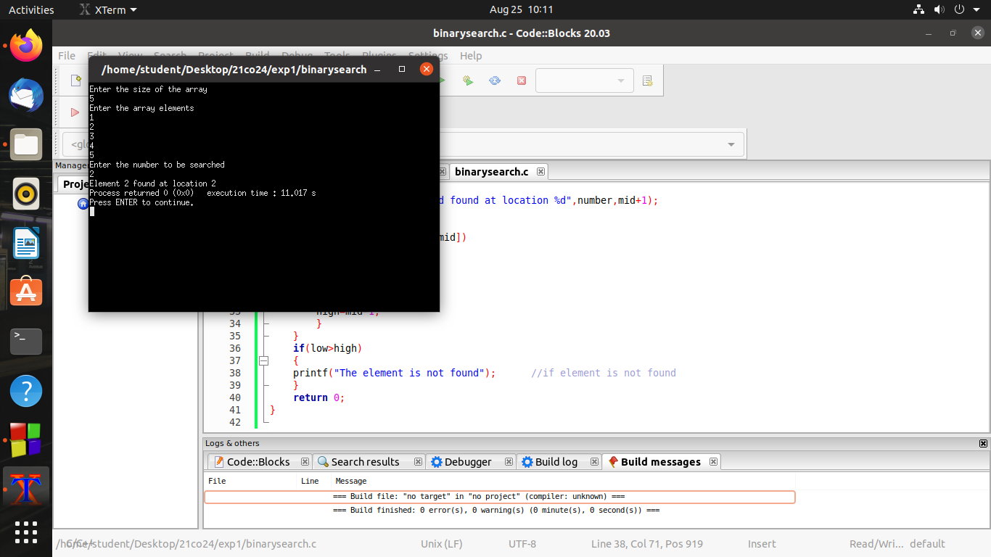

OUTPUT:Unsuccessful

